
RAMAIAH
Institute of Technology
USN | 1 | M | S

(Autonomous Institute, Affiliated to VTU)
(Approved by AICTE, New Delhi & Govt. of Karnataka) Accredited by NBA & NAAC with ‘A’ Grade

MAKEUP EXAMINATIONS – JULY 2019

Course & Branch | : | B.E. : Electrical and Electronics Engineering | Semester | : | VI
Subject | : | Power Systems – I | Max. Marks | : | 100
Subject Code | : | EE61 | Duration | : | 3 Hrs

Instructions to the Candidates:
- Answer one full question from each unit.

 |  | UNIT- I
1. | a) | Discuss the major advantages of per unit system. | CO2 | (08)
 | b) | The one line diagram of an unloaded power system is shown in Fig.1(b). Reactances of the two sections of the transmission lines are shown. The generators and the transformers are rated as follows. Draw the impedance diagram with all reactances marked in pu. Choose a base of 50MVA, 13.8kV in the circuit of generator1.  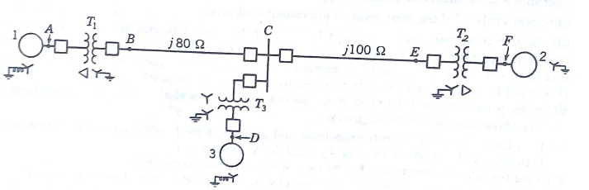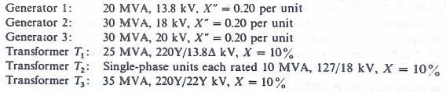 | CO1 | (12)
2. | a) | Explain sub-transient, transient and steady state current in a synchronous machine. | CO2 | (06)
 | b) | Draw the pu reactance diagram for the power system shown in fig. 2(b).Use a base of 50kVA, 13.8kV in the 40Ω line. The ratings of the generators, motor and transformers are given below.  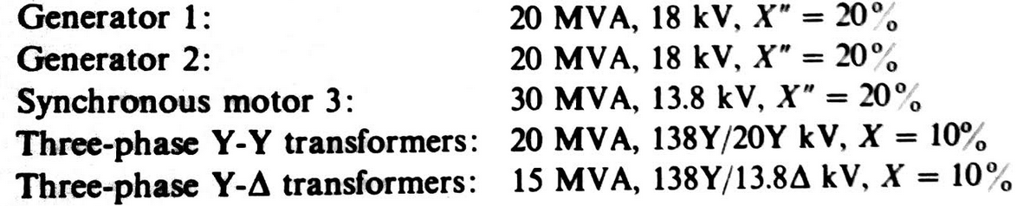  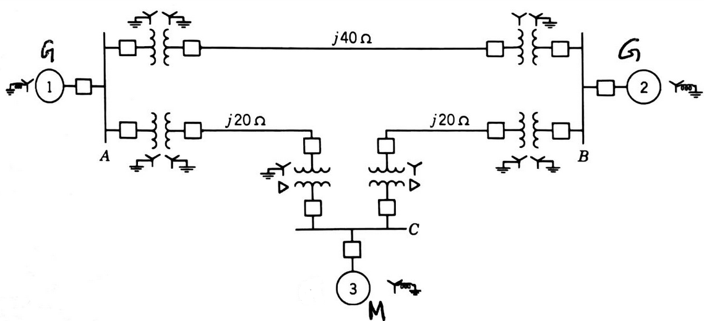  Fig. 2(b) | CO1 | (14)
 |  | UNIT - II
3. | a) | Explain the relation between sequence components of phase and line voltages in a star connected system with the help of phasor diagram. The positive and negative sequence components of phase voltages of a 3 phase system are V_{a1} =230∟30⁰V, V_{a2} =60∟60⁰. Determine the positive and negative sequence components of line voltages and hence the line voltages. | CO4 | (12)
 | b) | Explain the power calculation in terms of symmetrical components | CO4 | (08)
4. | a) | When a generator has terminal ‘a’ open and other two terminals are connected to each other with a short circuit from this connection to ground, typical values for the symmetrical components of current in the phase a are I_{a1}=600∟-90⁰, I_{a2}=250∟90⁰, I_{a0}=350∟90⁰ A. Calculate the current in each phase of the generator and the current in the neutral conductor. | CO4 | (10)
 | b) | Explain the winding diagram and voltage phasors for a three phase transformer connected Y-Δ where Y side is the high tension side. Also draw the corresponding labeling of line connection. | CO3 | (10)
 |  | UNIT- III
5. | a) | What are sequence impedances? Draw the single phase zero sequence networks for the transformers connected in different configuration. | CO4 | (08)
 | b) | If a circuit is composed of 3 unsymmetrical impedances, then prove that the currents of one sequence do produce voltage drops of other sequences. | CO4 | (06)
 | c) | Why the neutral grounding impedance appears as 3Z_{n}in the zero sequence network. | CO4 | (06)
6. | a) | Draw positive, negative and zero sequence networks for the power system shown in Fig.6(a). Corresponding data is as given below.  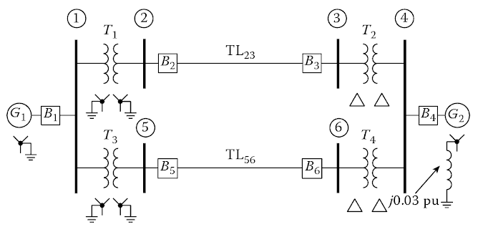  Fig.6(a)  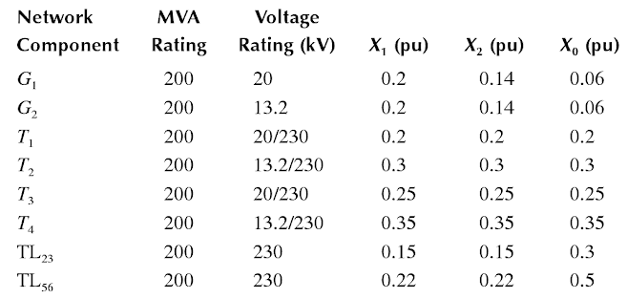  Assume generator 1 data as the common base. | CO4 | (14)
 | b) | Derive an expression for complex power in terms of symmetrical components. | CO4 | (06)
 |  | UNIT-IV
7. | a) | Derive the sequence network connections for an SLG fault in a power system. | CO4 | (08)
 | b) | A 20MVA, 13.8kV generator has a direct access sub-transient reactance of 0.25pu. Its negative sequence reactance is 0.35pu and zero sequence reactance is 0.1pu. The neutral of the generator is grounded, find the fault current, line-ground voltages and the line-line voltages for a double line-ground fault. | CO4 | (08)
 | c) | What are open conductor faults. What is their effect? | CO4 | (04)
8. | a) | Draw and explain the interconnection of sequence networks in case of double line to ground fault. | CO4 | (06)
 | b) | In a network, the magnitude of fault current for an L-G fault is 0.75pu and for an L-L fault it is 8.66pu. If the pre-fault voltage at the fault location is 1pu, determine the equivalent zero sequence impedance of the network. | CO4 | (06)
 | c) | Consider the power system shown in Fig.8(c). Compute the fault current for an L-L fault at F, if the system is initially on no load. The generator negative sequence reactance is 70% of positive sequence reactance.  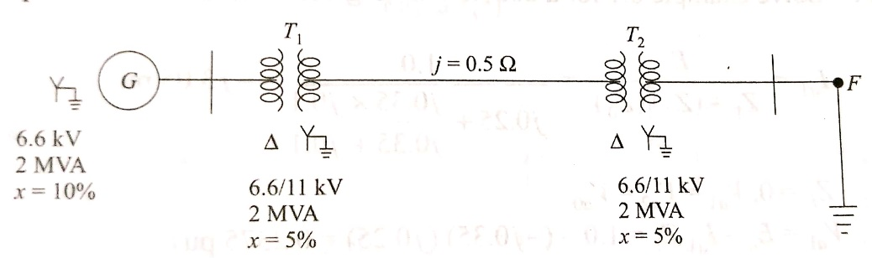  Fig.8(c) | CO4 | (08)
 |  | UNIT- V
9. | a) | A 60Hz four pole turbogenerator rated 500MVA, 22kV, has an inertia constant of H=7.5MJ/MVA. Find i)the kinetic energy stored in the rotor at synchronous speed and ii) the angular acceleration if the electrical power developed is the 400MW when the input less the rotational losses is 740,000hp. | CO5 | (14)
 | b) | Explain the factors affecting the transient stability. | CO5 | (06)
10. | a) | Explain the power angle equation. The single line diagram shown in Fig.10 (a) shows a generator connected through parallel transmission lines to a large metropolitan system considered as an infinite bus. The machine is delivering 1pu power and both the terminal voltage and the infinite bus voltage are 1 pu. Numbers on the diagram indicate the values of reactances on a common system base. The transient reactance of the generator is 0.2puas indicated. Determine the power angle equation for the system applicable to the operating conditions.  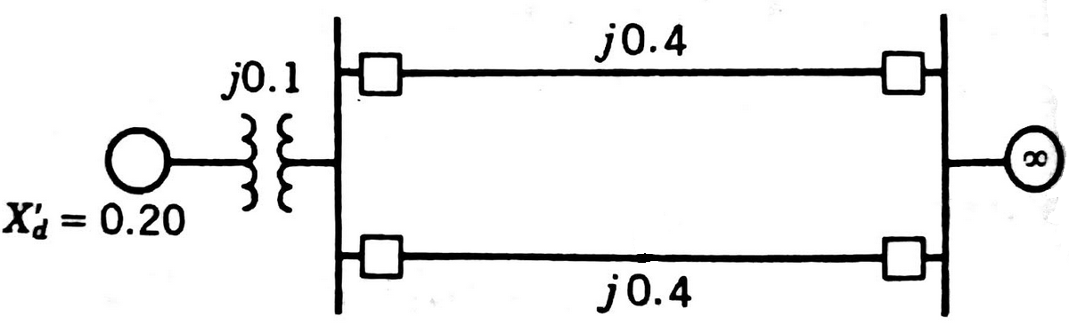  Fig.10(a) | CO5 | (15)
 | b) | Briefly explain various aspects of power system stability. | CO5 | (05)

****************

